MAKERERE UNIVERSITY

SCHOOL OF COMPUTING AND INFORMATION TECHNOLOGY

COURSE: Professional Project 1

GROUP 4

NAMES

1. BAHINDI EMMANUEL 19/U/12140/PS
2. MUGAMBA BRUNO M.H 19/U/8859/EVE
3. YASMIN HASSAN 19/U/12273/PS
4. SSEMAKULA STUART 19/U/12487/PS
5. KAVUMA MARK 19/U/12292/PS

**TABLE OF CONTENTS**

**1. INTRODUCTION 1**

1.1 Purpose 1

1.2 Scope  1

1.3 Overview  2

1.4 Reference Material  2

**2. SYSTEM OVERVIEW 2**

**3. SYSTEM ARCHITECTURE 3**

3.2 Decomposition Description 6

3.3 Design Rationale 9

**4. DATA DESIGN 10**

**Assignment table 13**

**5. COMPONENT DESIGN 14**

**6. HUMAN INTERFACE DESIGN 17**

**7. REQUIREMENTS MATRIX 22**

**8. APPENDICES 22**

# 1. INTRODUCTION

The Software Design Document is a document that provides documentation which will be used to aid in the development of the covid19 management and reporting System by providing the details for how the software should be built. Within the Software Design Document are narrative and graphical documentation of the software design for the project including use case models, sequence diagrams, collaboration models, object behavior models, and other supporting requirement information.

* 1. **Purpose**

This software design document describes how the covid19 management and reporting System is designed. It also explains the architecture of the software, shows the models and explains the way the software works. The intended audiences of this document are the covid19 management and reporting System users, software developers and system design analyst.

* 1. **Scope**

The Software Design Document covers the design of the covid19 management and reporting System from registration of covid19 health officers, automatic assignment of a general referral hospital and updating of their statuses, registration of all donor money into the web interface, and distribution of an excess of 100 million to the stakeholders, submission of details of covid-19 cases ­and producing of reports as per the request or requirements of a given user of the system.

* 1. **Overview**

Section 1 and Section 2 provide a general overview of the document and prepare the reader so that he/she understands the sections that follow.   
Section 3 describes the architecture of the system which is a conceptual representation of components and sub components that reflect the behavior of a system.  
Section 4 describes the data elements to be used in the covid19 management and reporting System and how they interact with each other to satisfy various states of the system

**Section 5** outlines the components of the system and describes what each component does in a more systematic way.  
Section 6 provides information about the application to the end user. The rest of the document is meant for the system developers of the covid19 management and reporting System. The sections are broken down as follows.

* 1. **Reference Material**

*This section is optional*

1.5 **Definitions and Acronyms**

Here are definitions for the acronyms that will be used throughout the document;  
API -Applications Programming Interface

# 2. SYSTEM OVERVIEW

The Ministry of Health in Collaboration with the World Health Organization has embarked on a project aimed at providing efficient covid-19 case management and reporting in Uganda. In this project, health officers stationed among the 155 hospitals (private and public) in Uganda will be responsible for reporting covid-19 cases, clearly indicating both positives and false positive cases. Hence, the need for a comprehensive and effective stakeholder satisfaction scheme that would fully avail all the required relevant information that any of the intended users might need.

The Covid-19 management and reporting system is a web based application, whose web interface is developed in la-ravel, a PHP framework. The client and server application is developed in C programming language i.e. for the client it communicates to the API's via the HTTP protocol using GET and JSON scripts, which in turn interacts with an SQL database on the server side.

With the covid19 management and reporting System, a systems administrator registers covid-19 health officers, a covid-19 health officer is able to submit the details of covid-19 cases, submit new patient list, add patient list to the patient file, check status of the file, submit new patient from the file, search and view a record from file by date or name. Access to the application is upon completion of the registration process to which one ought to have a valid username and password.

The system follows a client server architecture where client sends requests to the server and a response returned accordingly.

The system is intended for covid-19 health officers who will interact with it in different ways to gain access to relevant information in regards to covid-19 or any other concerns they may have.

# 3. SYSTEM ARCHITECTURE

**3.1 Architectural Design**

The system uses a 3-Tier client/server model which consists of client machines, application components and a database server.

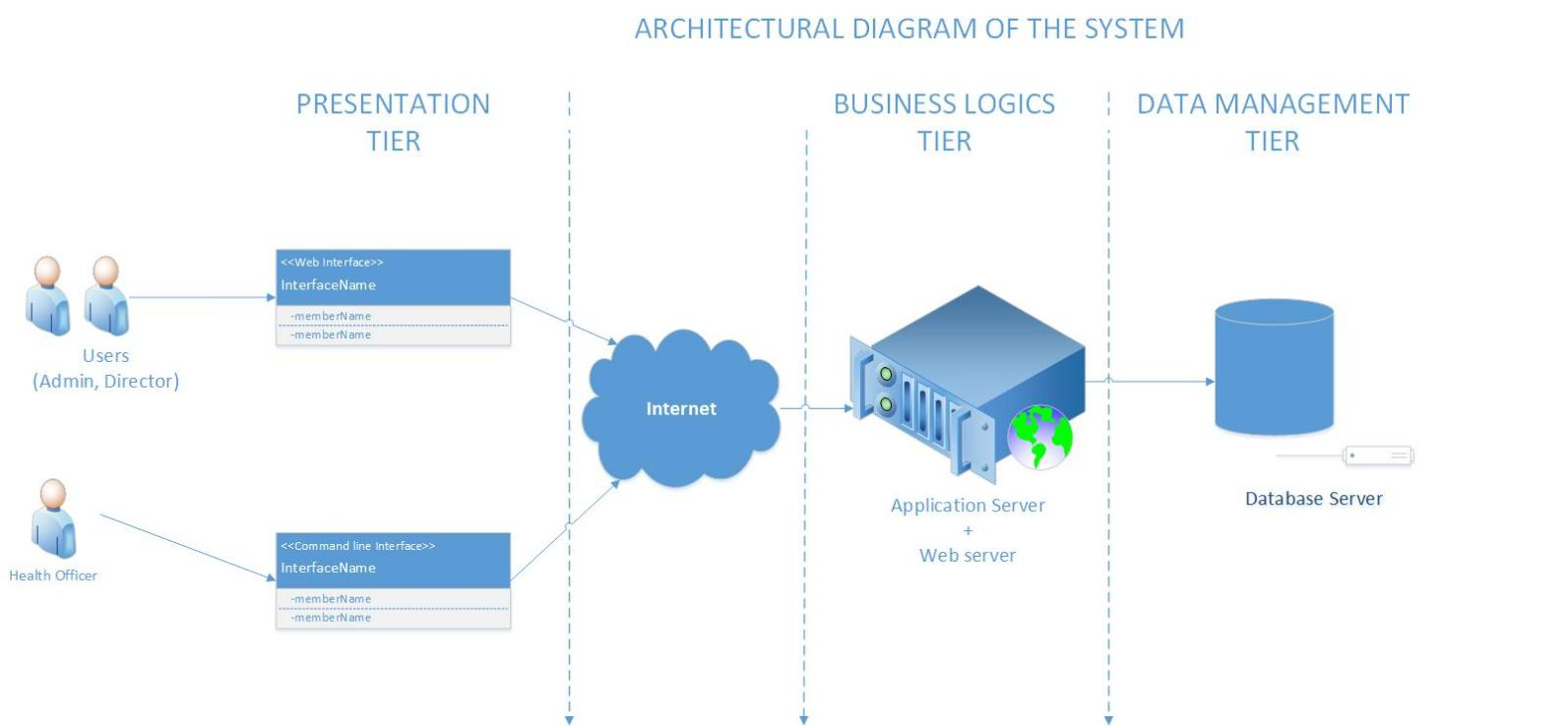

**Figure 3‑1 Architectural design of the system**

**Web Interface**

This will provide a web application layer for capturing health officer details during registration of health officers by the administrator after which these details will be stored in a database.

The system administrator registers the health officers and the system automatically assigns them respective hospitals. In addition, the web interface will be used by the administrator to declare and register funds received from the donors. All health officers in the 155 hospitals will be viewed by the administrator through the interface.

The system upgrades health officers who have attended to 100 covid-19 patients regardless weather some died or not, and assigns him or her a respective hospitals.

**CLI**

The component will provide a command-line prompt that health officers shall use to add patient details. The patient details will be saved in files for each hospital and stored in the database. Health officers will use the interface to check for file statuses and referral statuses for each patient. Results for the status checks will be retrieved through the command-line interface.

**File check**

The file check component will run under a scheduled program that checks the completeness and validity of the enrollment files every 5 minutes from the database. A complete file is one which has all agent signatures attached to the bottom of the files, a valid file is one where all signatures are correct. The program returns error messages to for those files that are not valid and complete. Once the check is passed, the contents of the files are cleared and a copy is saved in the database.

**Referrals**

All referrals will be initiated by general hospitals to regional

Hospitals and from regional to national referral hospitals. All the referrals are entered into the system by the health officer and the system stores the records I to the data base

**Health officer payment**

The system monitors all the payments made to all the different health officers in there specialized categories.

The system Administrator registers all the donations made into the system and all the salary and bonus payments are made from the available donor funds.

## **3.2 Decomposition Description**

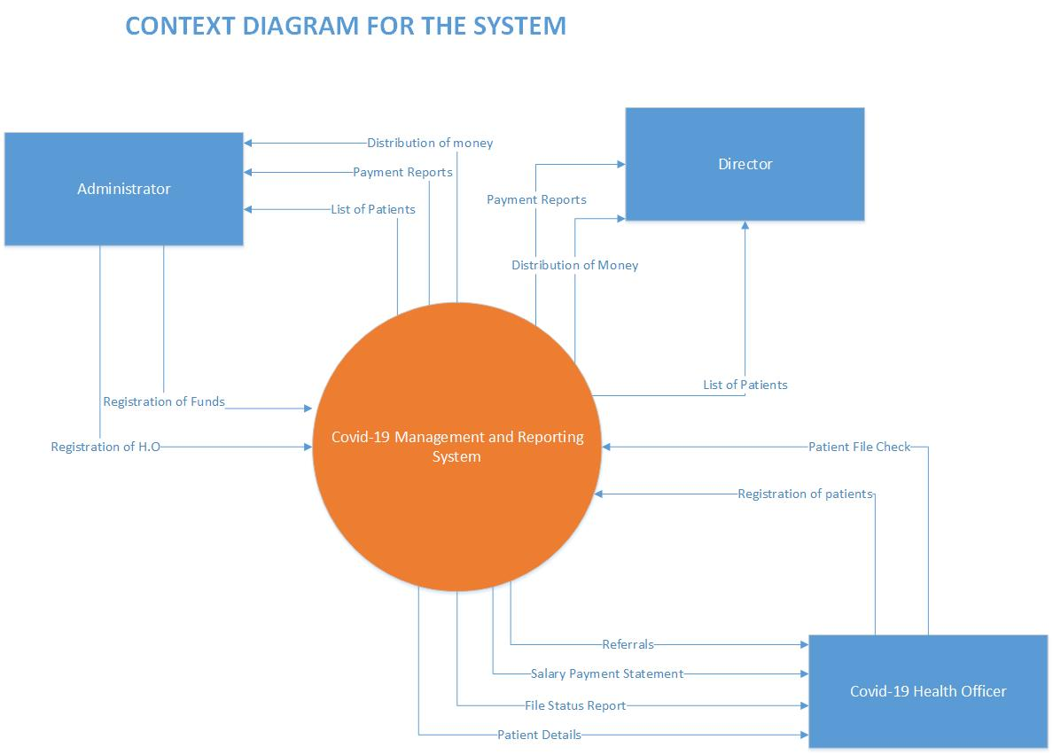

**Figure 3‑2 Context diagram for the system**

**Description**

Administrator enters health officer details, registers funds and the system upgrades a health officer by changing their levels to a higher level. The administrator is able to view patient lists and health officer lists using the web application.

The administrator also views the treasury status which shows available funds.

The health officer enters patient details, check their covid status, and check file status through a command line interface. Health officers are able to view the file status, their covid-19 status, and their registration profiles.

The system automatically generates id’s for the patients indicating clearly there names and health status.

**Level 1 Data flow diagram for the system**

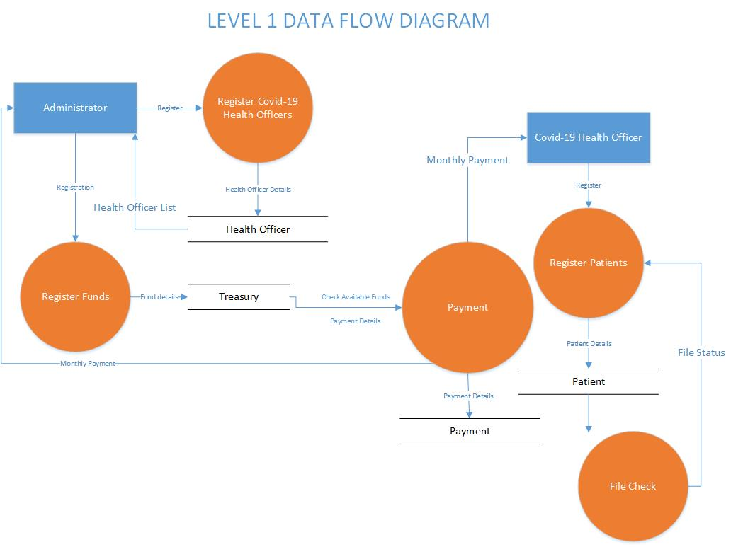

**Figure 3‑3 Level 1 Data flow diagram for the system**

**Description of the diagram**

**Process 1 Register funds**

The administrator declares and registers funds which are donated by well-wishers. The funds are then stored in the treasury. The administrator also views the treasury status which shows available funds.

**Process 2 Register of health officers**

The administrator enters health officer details which include name, gender, and signature. The health officers’ details are then stored in agent information files. The administrator views the health officer’s lists using the web application.

**Process 3 register of patients**

The health officer registers the details of the patient. These details include the name of the patient, date of identification, if a patient is asymptomatic or symptomatic, gender of the patient, username for a covid-19 health officer who

Submits the details. The ID of the patient is automatically generated by the system.

**Process 4 File check**

The health officer enters a file check command which checks the district files for completeness and validity, after which the file status is returned to the health officer

**Process 5 Payment**

The payment process checks the treasury for available funds. If the funds are above 100 million payment is made to the administrator and health officers basing on the fractions each has to get.

**Process 6 Recommend check**

This process checks the district files for health officers who have attended to over 100 patients and returns the results from this check to the administrator.

**Process 7 Change patient status**

After getting the lists of health officers who have attended to more than 100 patients, the system upgrades those health officers to higher positions as long as there is an available position in any hospitals. Having changed the health officers’ status, the files are updated i.e. they are deleted from current hospital files and then added to another hospital files.

## 

## **3.3 Design Rationale**

The purpose of using this architecture in 3.1 is to allow data exchange and divide the application processing across the components whereby the critical functions such as checking of file status, checking available funds, patient status, storing health officer’ and patient’ details, and registering funds will be processed on the server.

The client machines will process functions such as retrieving patient lists from the database, graphs and funds via the web application, checking of file status and payment status and submitting patient details using the command-line prompt.

The central shared data repository is to enable the components to store and easily access data items.

# 4. DATA DESIGN

4.1 Data Description

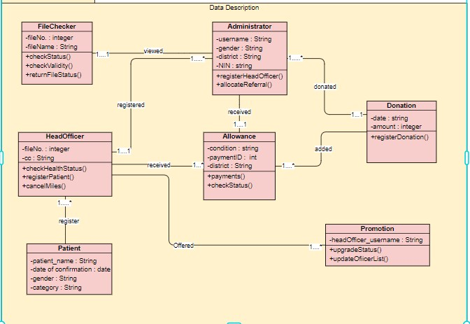

**Figure 4‑1 Class diagram for the system**

**Description of the class diagram**

The class diagram shows the objects in the system and their methods.

The file check object has check validity, check file status and return file status methods which check for the status and validity of the files and returns file status.

Register health officer object registers health officers, captures their signatures and allocates districts to the health officer. The registered health officer adds patients, , check file status and also check payment status.

Patient register object categories patients to lists and assigns IDs to patients registered which starts with the district initials. Patients with false covid-19 results is corrected and the lists updated

Change health officer status checks the number of patients he has attended to and automatically upgrades his status.

Register funds object declares and registers funds that have been received from well-wishers.

Payments object checks the treasury for available funds and distributes funds to administrator and health officers.

**4.2 Data Dictionary**

This is a set of information describing the contents, format, and structure of a database and the relationship between its elements, used to control access to and manipulation of the database.

**Table 1 . Health officers table**

This table stores information about each registered health officer

|  |  |  |  |  |
| --- | --- | --- | --- | --- |
| Field name | required | Data type | Max field size | description |
| ID | yes | VARCHAR | 10 | A unique identifier of each health officer |
| User name | yes | VARCHAR | 50 | The full name of each health officer |
| Gender | yes | VARCHAR | 15 | The sex of each health officer either male or female |
| Phone | Yes/no | VARCHAR | 20 | The number of a health officer |
| Email | Yes/no | VARCHAR | 20 | The email of a health officer |
| District | yes | VARCHAR | 15 | The district of a health officer |
| Nationality | Yes/no | VARCHAR | 10 | Country of origin of the health officer is from |

**Table 2. Administrator table**

|  |  |  |  |  |
| --- | --- | --- | --- | --- |
| **Field name** | **required** | **Data type** | **Max field size** | **description** |
| ID | YES | VARCHAR | 10 | **MUST BE UNIQUE** |
| Name | YES | VARCHAR | **20** |  |
| Phone | Yes/no | VARCHAR | 20 | The number of the administrator |
| Email | Yes/no | VARCHAR | 20 | The email of a health officer |

**Table 3.Patient table**

This table will be used to store information about each patient who is registered

|  |  |  |  |  |
| --- | --- | --- | --- | --- |
| Field name | required | Data type | Max field size | description |
| ID | yes | VARCHAR | 10 | Unique Identifier for each patient registered |
| Name | yes | VARCHAR | 50 | Name of each patient |
| Date _of _Identification | yes | VARCHAR | 10 | Date when each patient is identified |
| Gender | Yes | VARCHAR | 10 | Sex of the patient either male or female |
| Username for a covid-19 health officer | yes | VARCHAR | 50 | Name of the covid-19 health officer attending to particular patient |
| Status | yes | VARCHAR | 15 | Status of each patient either asymptomatic or symptomatic |

**Table 4. Payment table**

This table will store information about payments made to each staff

|  |  |  |  |  |
| --- | --- | --- | --- | --- |
| Field name | required | Data type | Max field size | Description |
| Payment ID | yes | VARCHAR | 10 | Identifier for each payment transaction made |
| Name | yes | VARCHAR | 10 | Name of the staff paid |
| Position | yes | VARCHAR | 15 | Hierarchy of the person either Admin,head of health officers director, staff |
| Date_of_payment | yes | DATE | 20 | The date to which payment is made |
| Status | yes | VARCHAR | 15  15 | Status of payment whether paid or not paid |

**Table5. Assignment table**

This table stores information how different covid _19 health officers are being assigned hospitals after registration

|  |  |  |  |  |
| --- | --- | --- | --- | --- |
| Field name | required | Data type | Max field size | Description |
| Health officer ID | yes | VARCHAR | 10 | A unique identification of a health officer |
| Type of hospital | yes | VARCHAR | 30 | This describes which hospital a health officer is assigned |
| Date of heath officer assignment | yes | Date | 10 | The date to which a health officer was assigned a specific general hospital |
| Assignment status | Yes/no | VARCHAR | 20 | The status of each health officer after being assigned a hospital either head, consultant etc. |

# 5. COMPONENT DESIGN

*In this section, we take a look at Psuedocode or algorithms for different modules in the system and communication mechanisms allocated to each part as indicated in the diagrams below.*

***Table .6 Psuedocode for different modules.***

|  |  |
| --- | --- |
| **Promotion module** | |
|  | **Psuedocode** |
| **Covid-19 Health officers** | **If treated patients = 100 Then**  **Print upgraded to senior official and assigned to Regional referral with < 100 (senior official).**  **End if** |
| **Senior Health official (Regional referral)** | **If makes positive cases = 900 Then**  **Print promoted to covid-19 consultant and awarded UGX10,000,000 then put on the waiting list to national Referral.**  **End if** |
| **Payments module** | |
| **If tune <= 100,000,000 Then**  **Print no payments.**  **End if**  **If tune > 100,000,000 Then**  **Print (Director) 5M basic salary plus 5% bonus of remaining.**  **(Superintendent):1/2 of basic & 1/2 of bonus of Director.**  **(Administrator): 3/4 of Superintendent.**  **(Covid-19 official): 8/5 of Administrator.**  **(Senior Covid-19 Official): earns 6% more than Covid-19 official.**  **(Head of Officials<<General hosp>>): earns 3.5% of what health official earns.**  **End if** | |
| **File Check module** | |
| **If New case in 5minutes Then**  **Print Clean respective files after**  **Cases inserted into the database.**  **End if** | |

**Administrators and Directors interaction with the system.**

**The Administrators and Directors use the website to retrieve list of patients, distribution of money to both staff and health officers, and the total number of patients.**

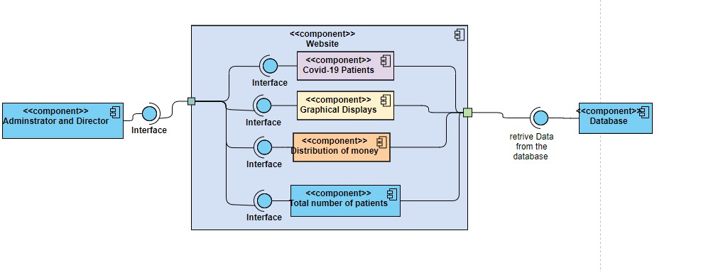

**Fig:5-1 Showing how administrators and directors use the web to view data**

**Covid-19 Health Officials interaction with system**

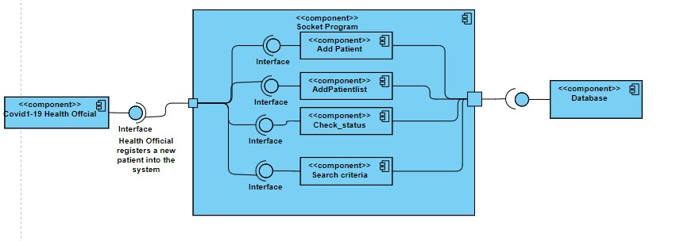

***Fig:5-2 Showing how health officers use the command line to enter patient credentials.***

**Administrators using the registration module**

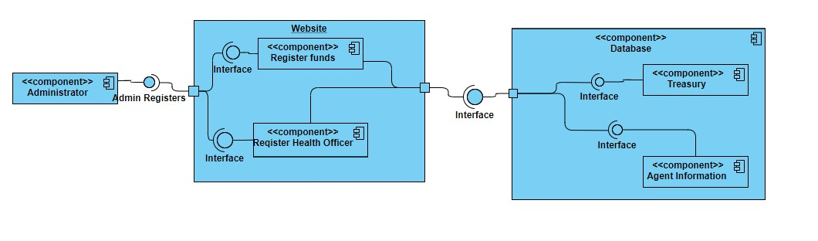**Fig:5-3 Showing how administrators use the web register health officers and donations.**

# 6. HUMAN INTERFACE DESIGN

**6.1 Overview of User Interface**

Fig:6-1 Showing the homepage of the web application to be used by administrators and directors plus the donators.

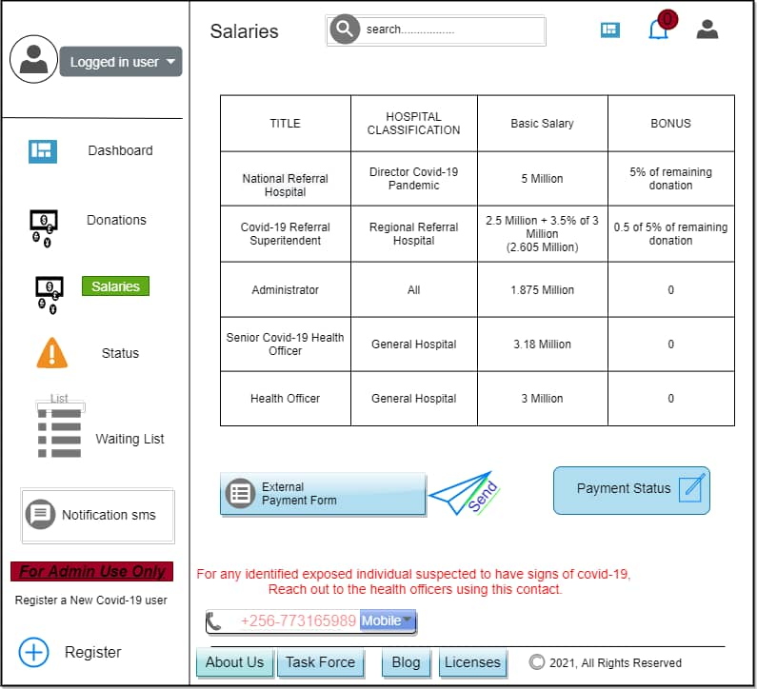

**6.2 Screen Images**

Fig:6-2 Showing a list of health officers at a given health referral the number of patients treated.

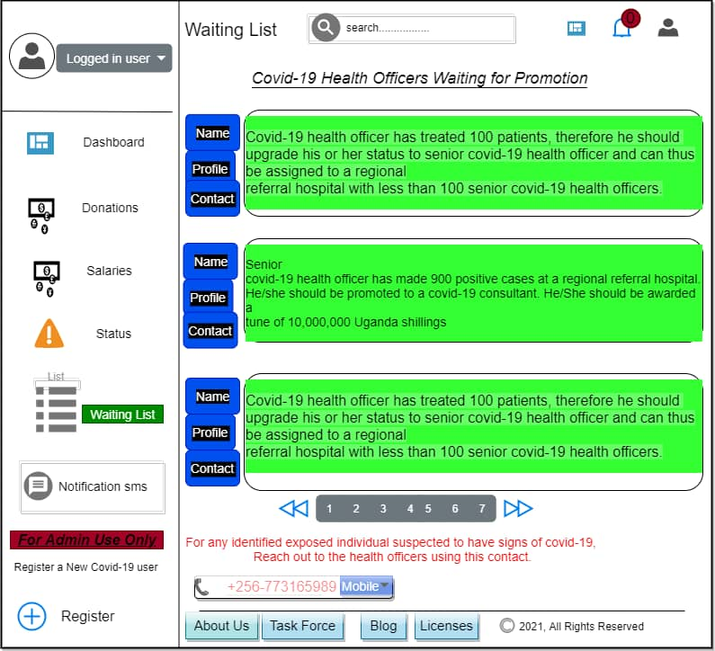

Fig: 6-3 Showing the new covid-19 case being updated every after five (5) minutes plus the statistics of the covid-19 cases

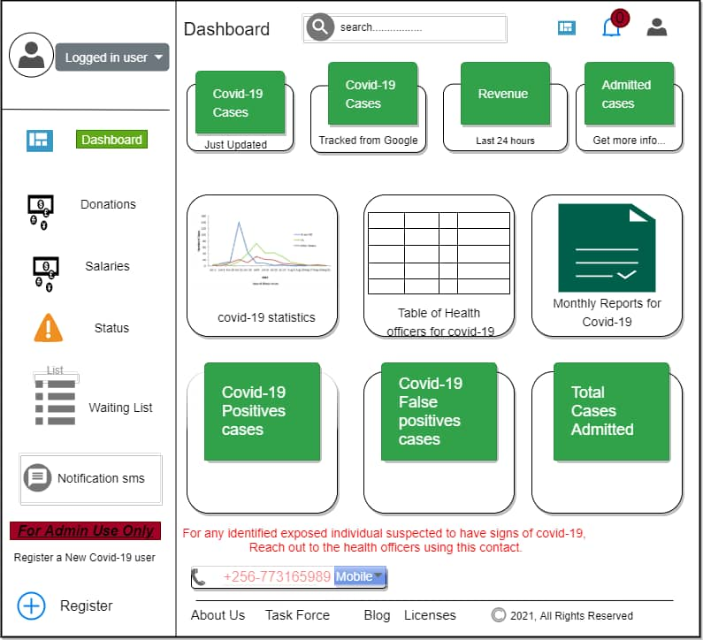

**6.4 Screen Objects and Actions**

***Fig:6-4 Showing how new health officers can register with web.***

. 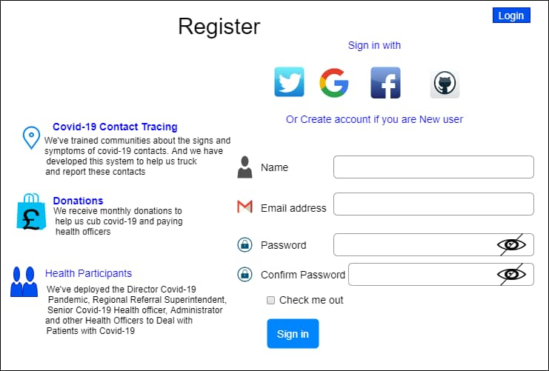

# REQUIREMENTS MATRIX

**Table.7 Indicating the different requirements needed for design of covid-19 Management System.**

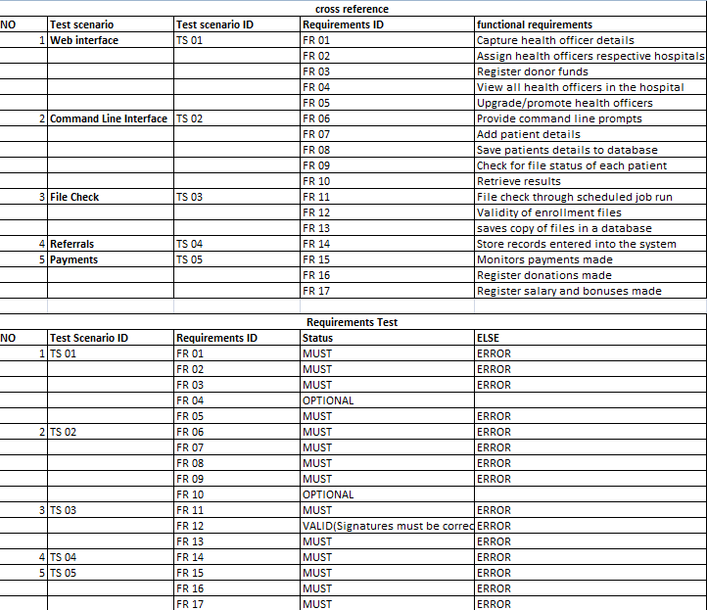

# 8. APPENDICES

This section is optional.